**API’s Screenshots using Swagger**

Name: Reham Bousaleh

Date:1 Dec 2021

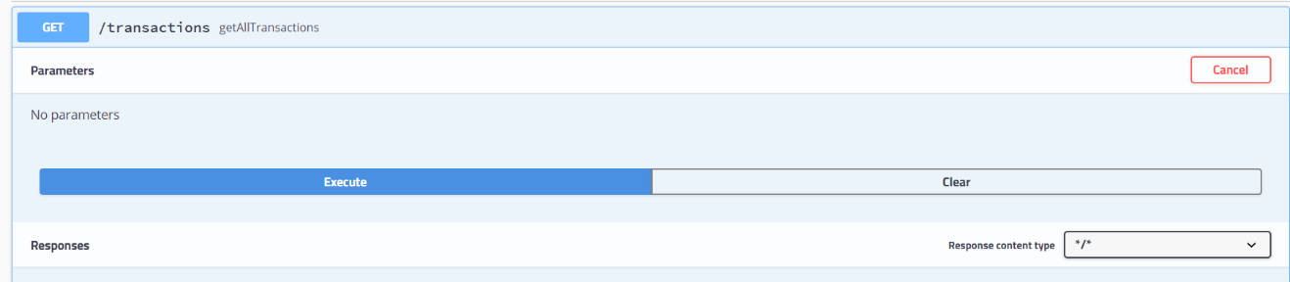Display All Transactions:

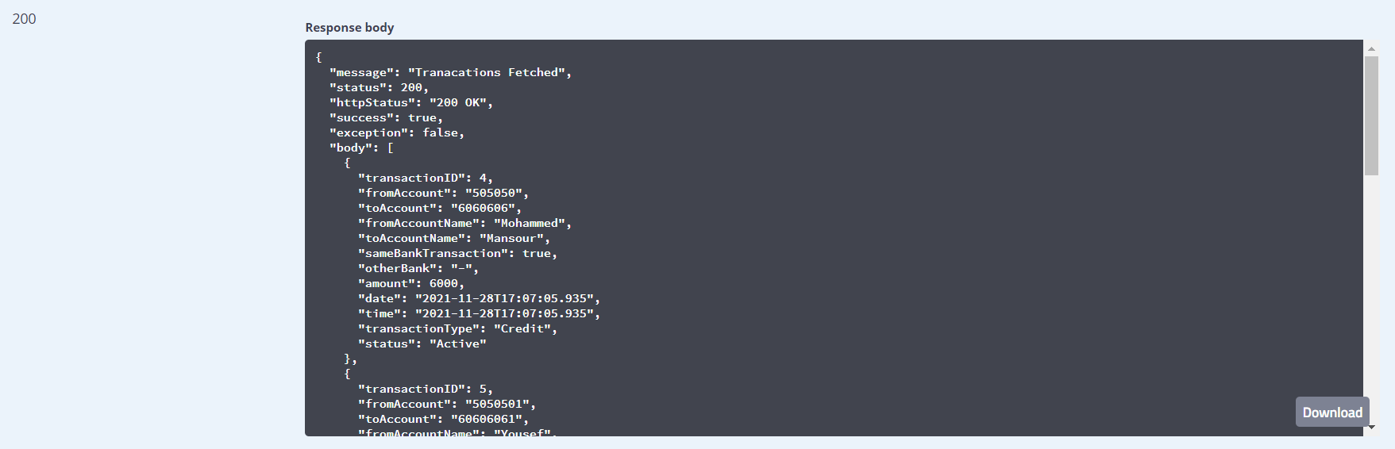

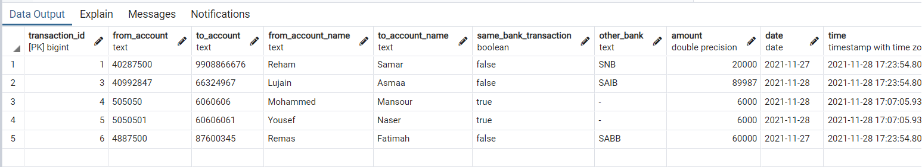5 transactions are available:

Adding Transaction:

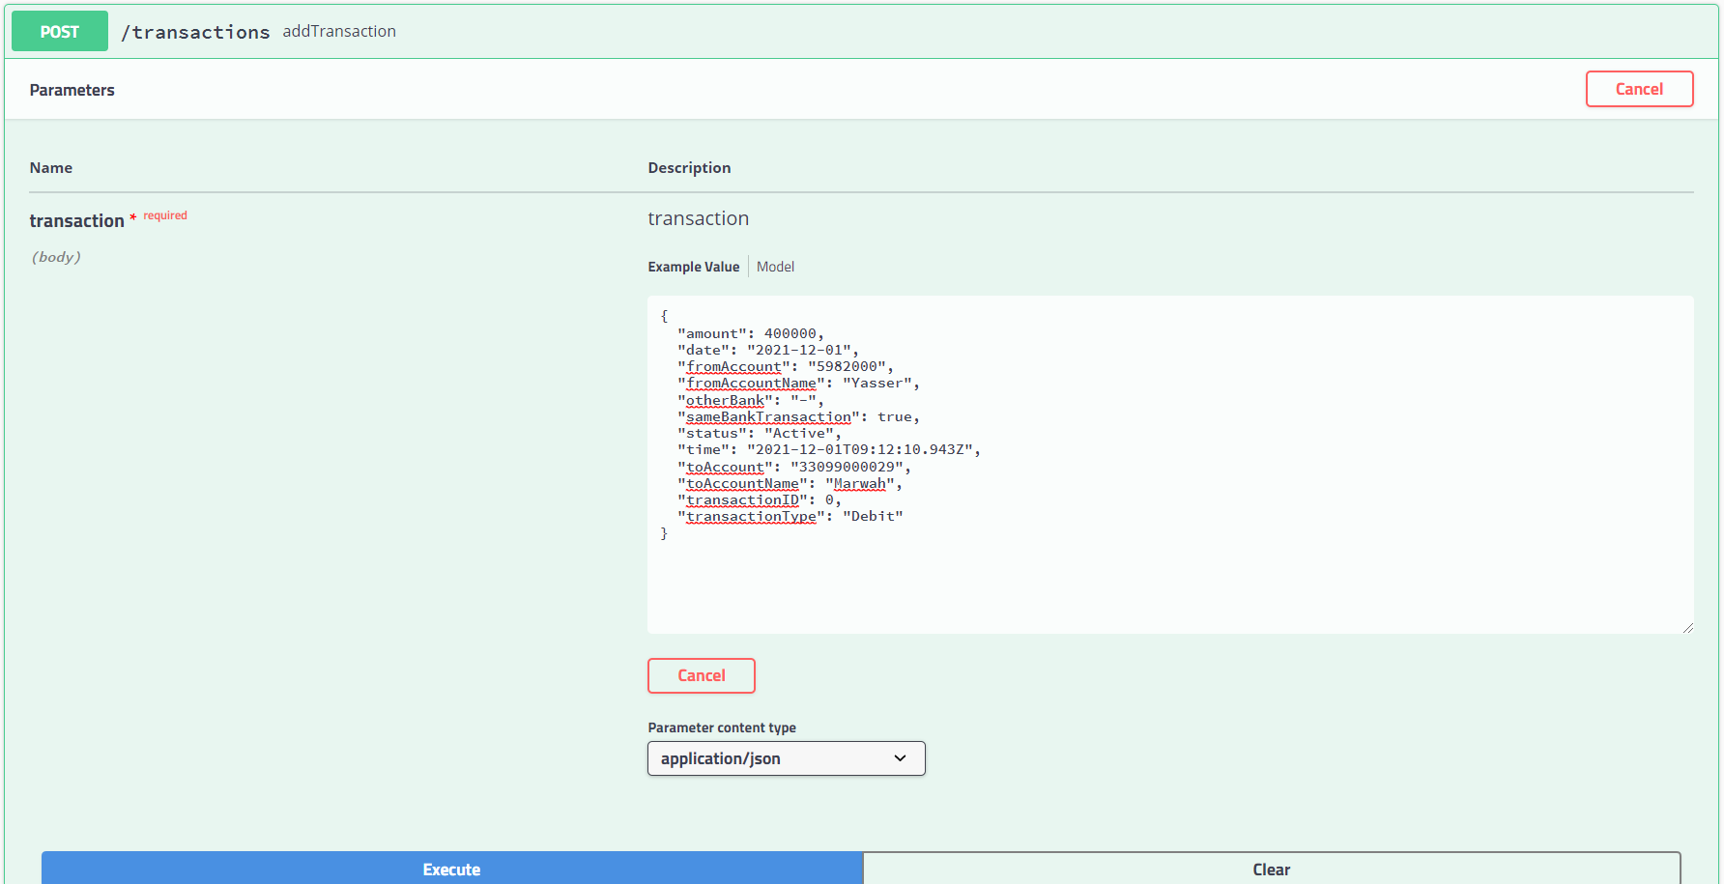Date should be in format of” yyyy-mm-dd

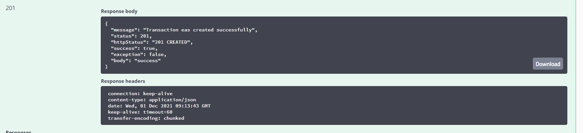

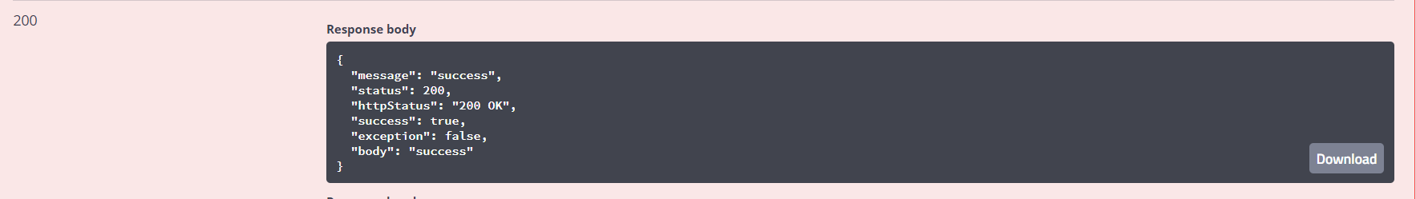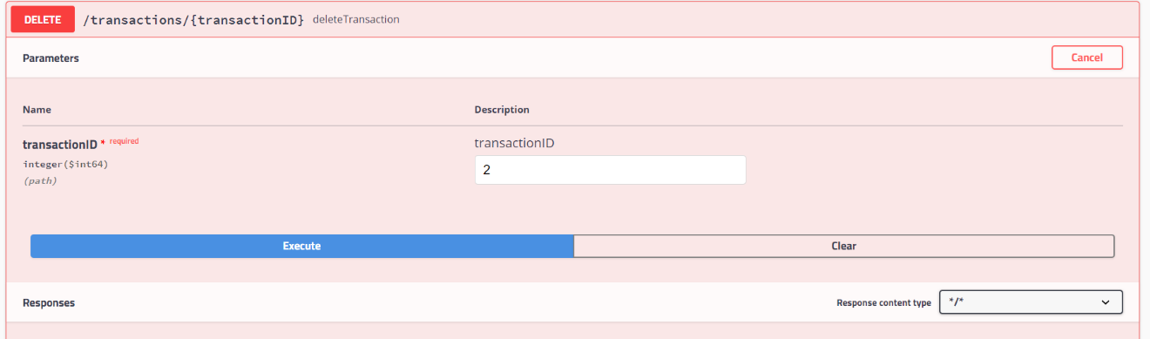Delete Transaction:

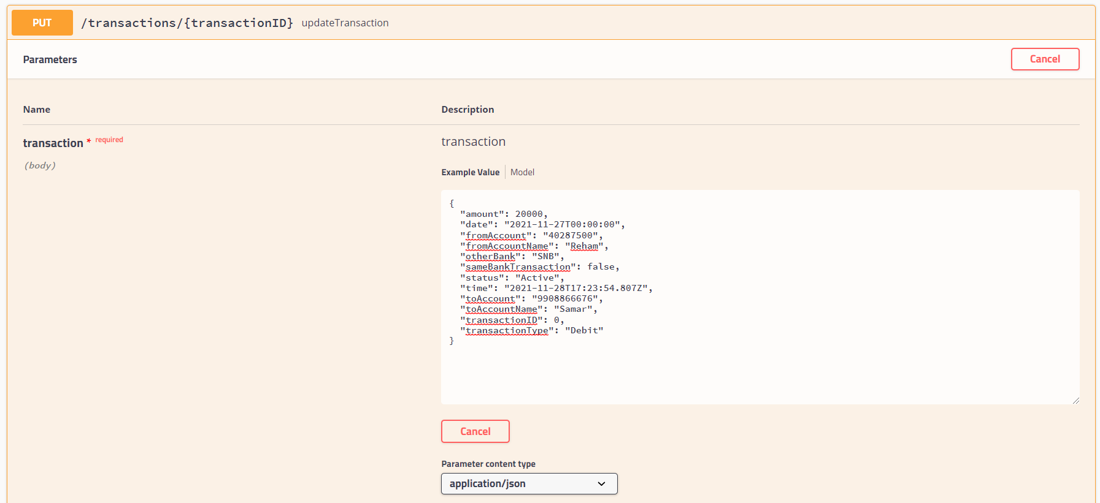Update Transaction:

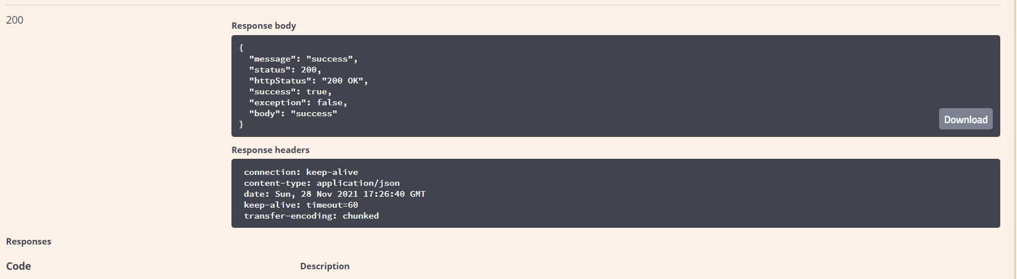

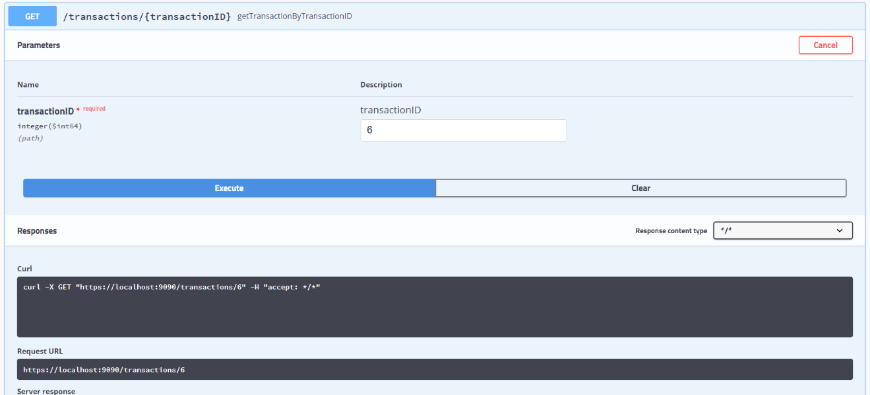Look Up Transaction by Transaction ID:

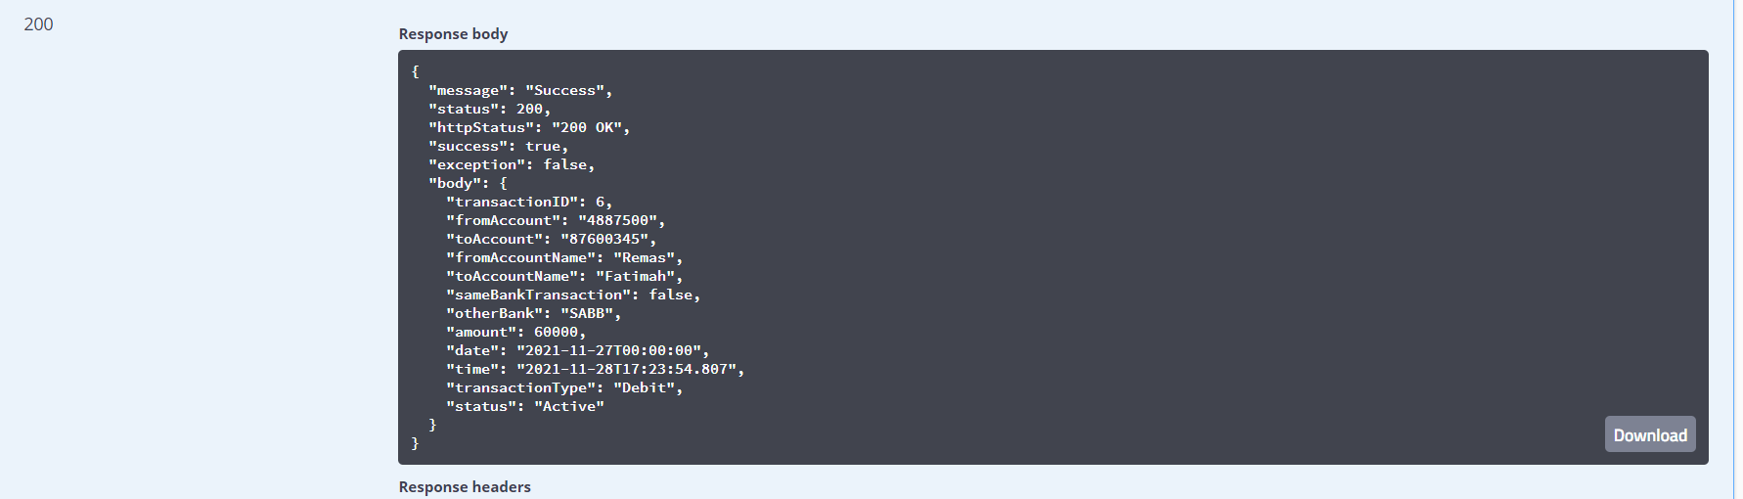

Pagination:

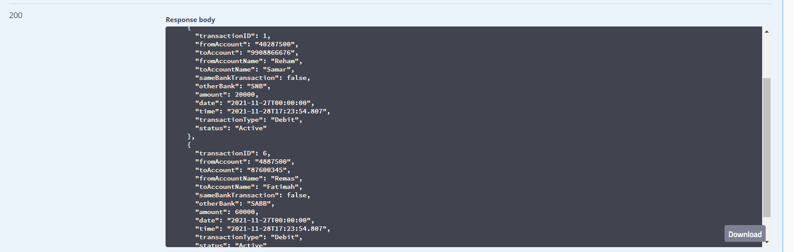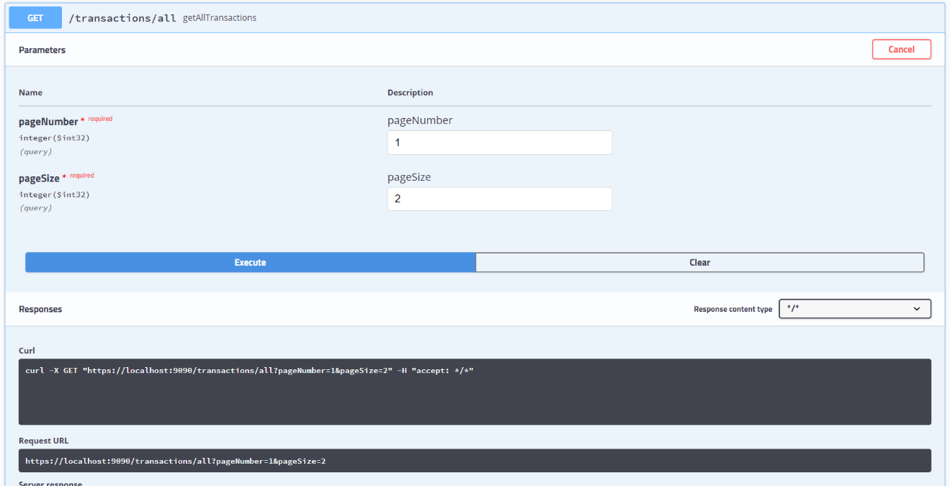Pagination without Sorting:

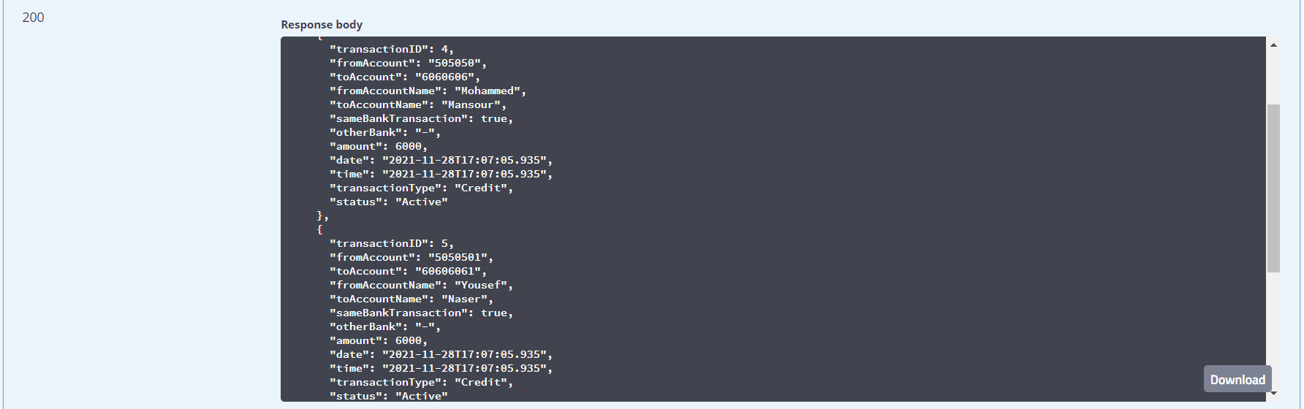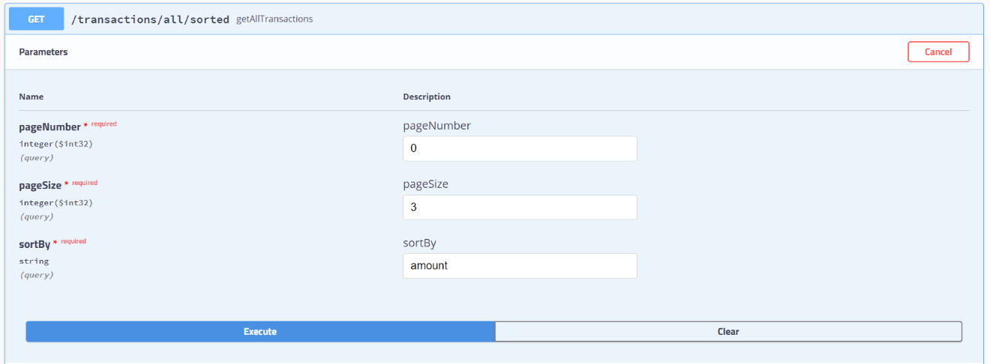Pagination with sorting:

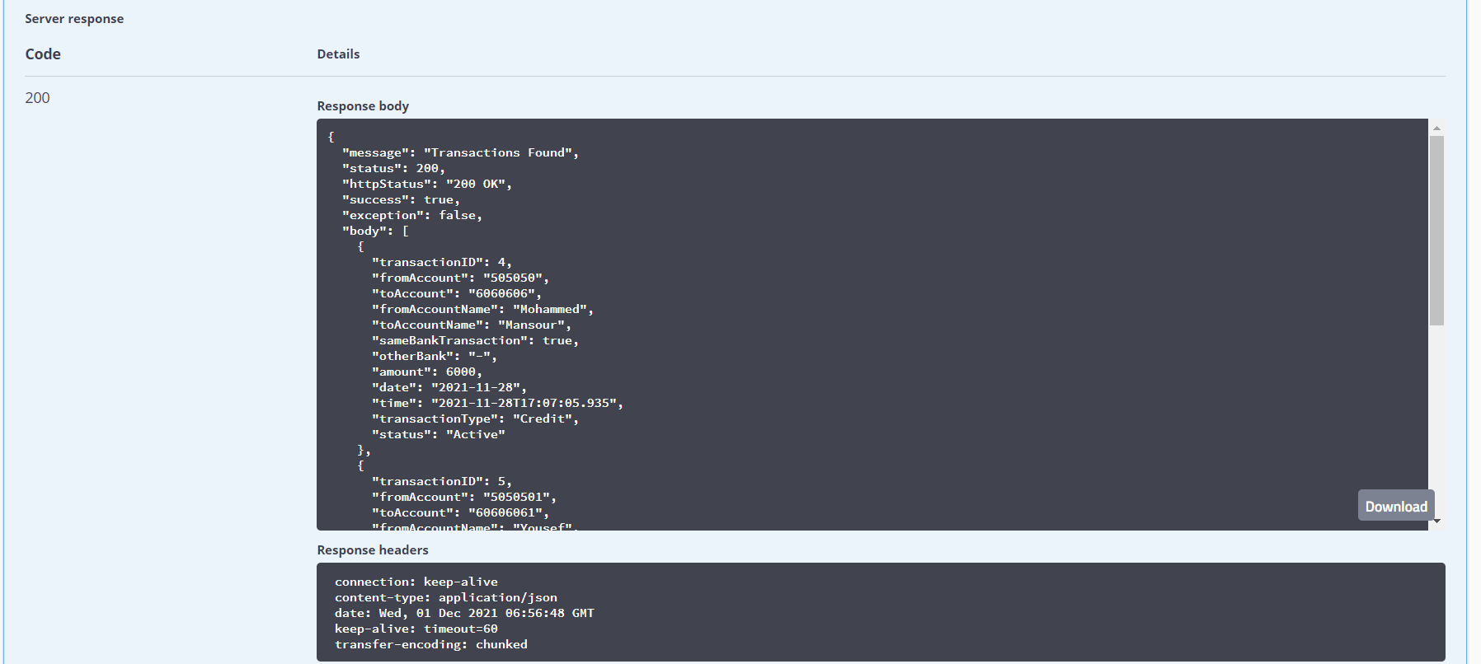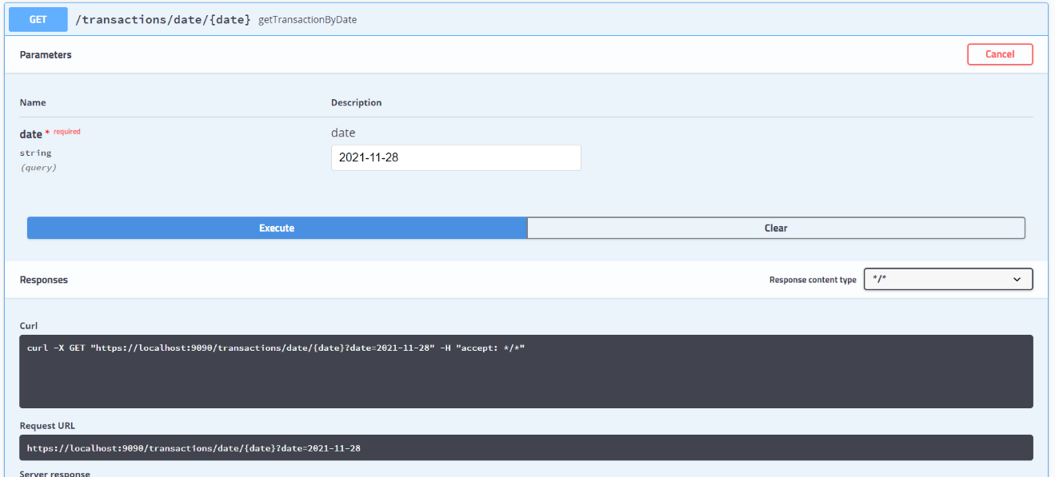Filter Transactions by Date:

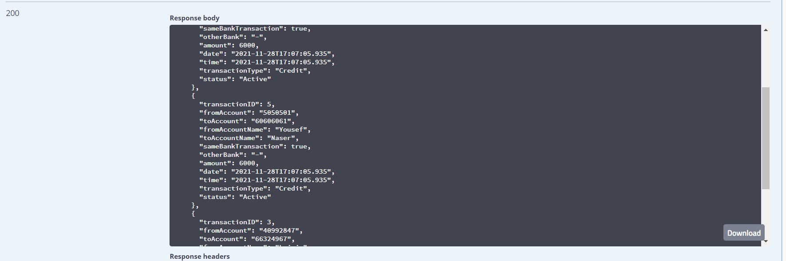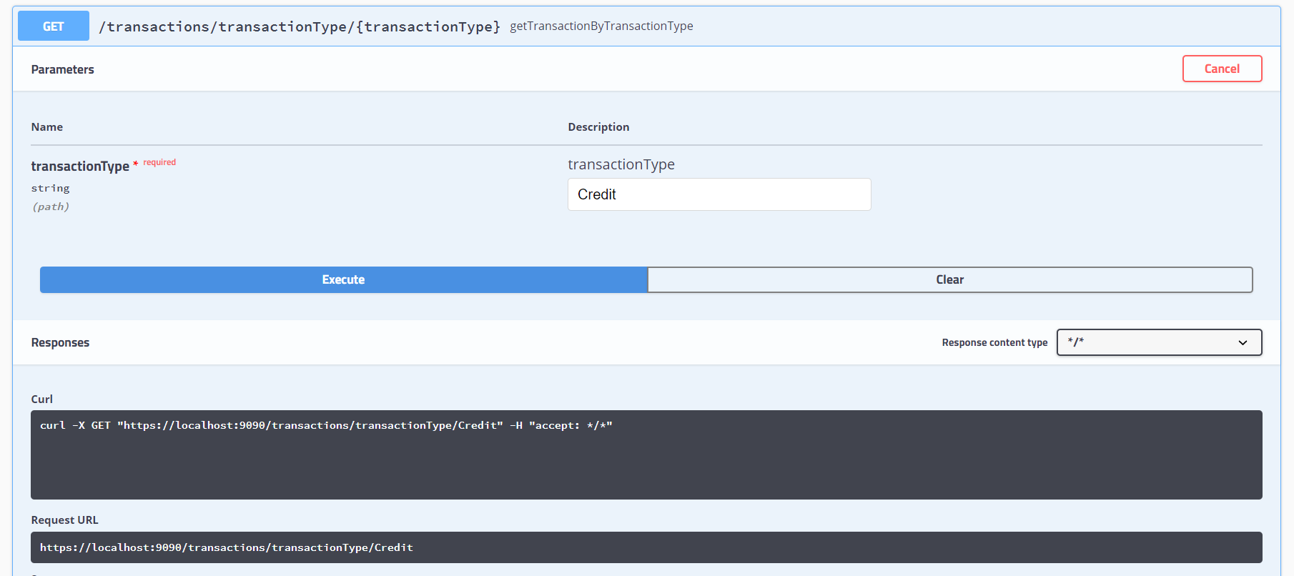Filter Transactions by Type:

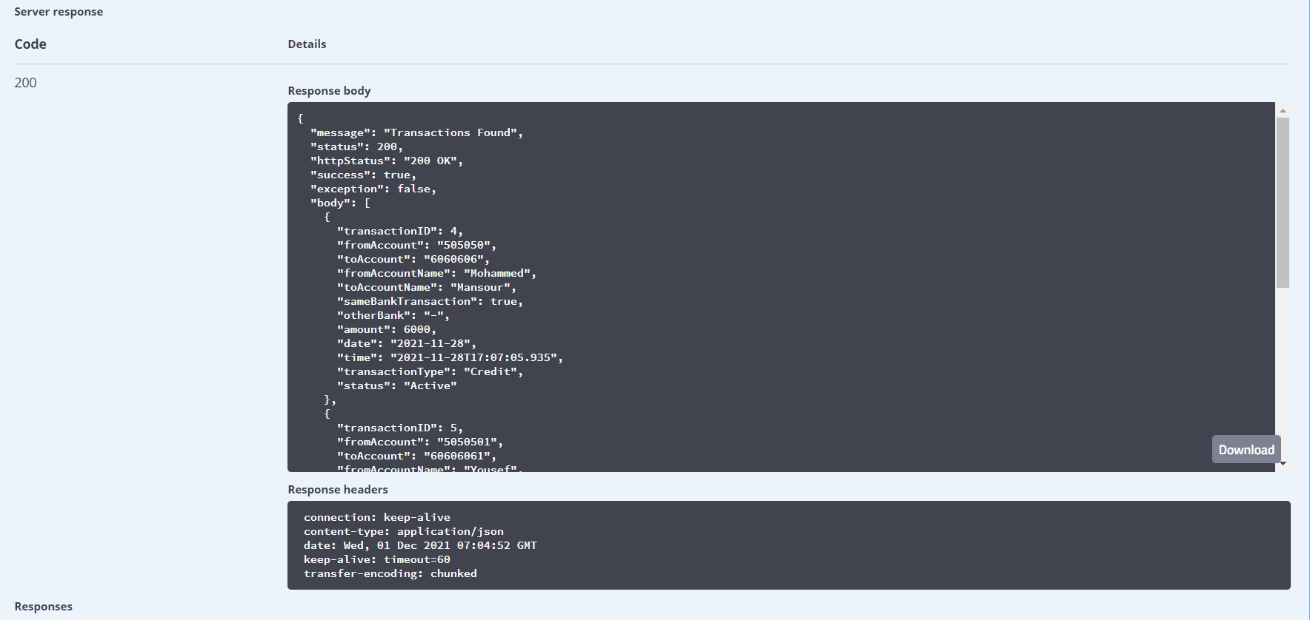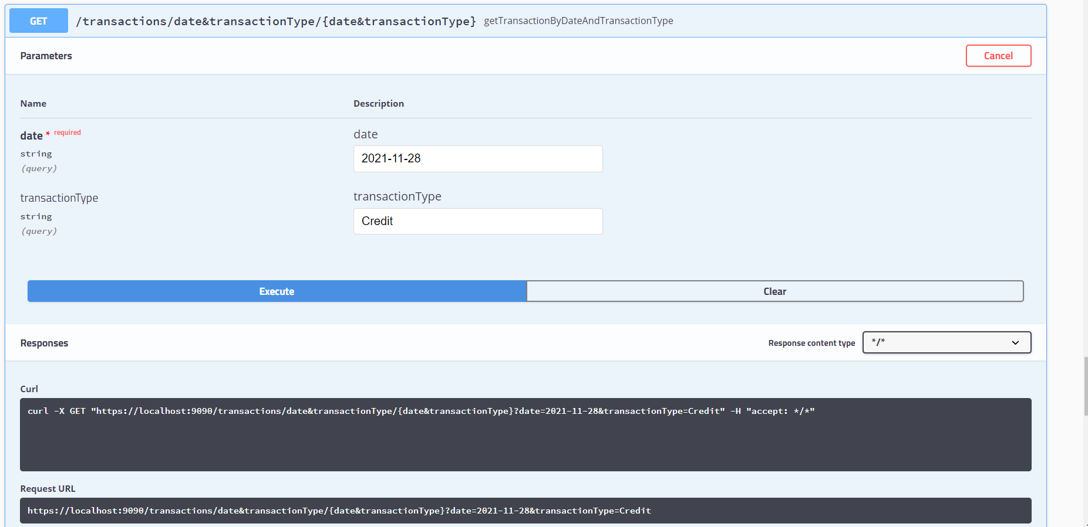Filter Transaction By Date and Type:

GitHub Repository Link :

<https://github.com/RehamKM98/saib-capstone-project>